**DAILY ONLINE ACTIVITIES SUMMARY**

|  |  |  |  |  |  |  |  |  |
| --- | --- | --- | --- | --- | --- | --- | --- | --- |
| **Date:** | **27/05/2020** | | | | | **Name:** | **AKASH S** | |
| **Sem & Sec** | **4TH&A** | | | | | **USN:** | **4AL18CS004** | |
| **Online Test Summary** | | | | | | | | |
| **Subject** | | **MICRO PROCESSOR AND EMBEDED SYSTEM** | | | | | | |
| **Max. Marks** | | **20** | | **Score** | | | **19** | |
| **Certification Course Summary** | | | | | | | | |
| **Course** | **INTRODUCTION TO PYTHON PROGRAMMING** | | | | | | | |
| **Certificate Provider** | | | **UDEMY** | | **Duration** | | | **4.5 HOURS** |
| **Coding Challenges** | | | | | | | | |
| **Problem Statement:1:** C program to find digital root of a number | | | | | | | | |
| **Status: executed** | | | | | | | | |
| **Uploaded the report in Github** | | | | | **YES** | | | |
| **If yes Repository name** | | | | | **1.https://github.com/akashacharya786/lockdown-coding/blob/master/Palidrome**  **2.** **https://github.com/akashacharya786/lockdown-coding/blob/master/Palidromestack.java** | | | |
| **Uploaded the report in slack** | | | | | **YES** | | | |

Online Test Summary: 18CS45 online test was scheduled from 9:15am to 9:45 am. The portion for the IA was 5th module. The question were MCQ type There were 30 question 1 mark respectively duration is 30 minutes .The score I received was 28/30.

**Snop shot:**

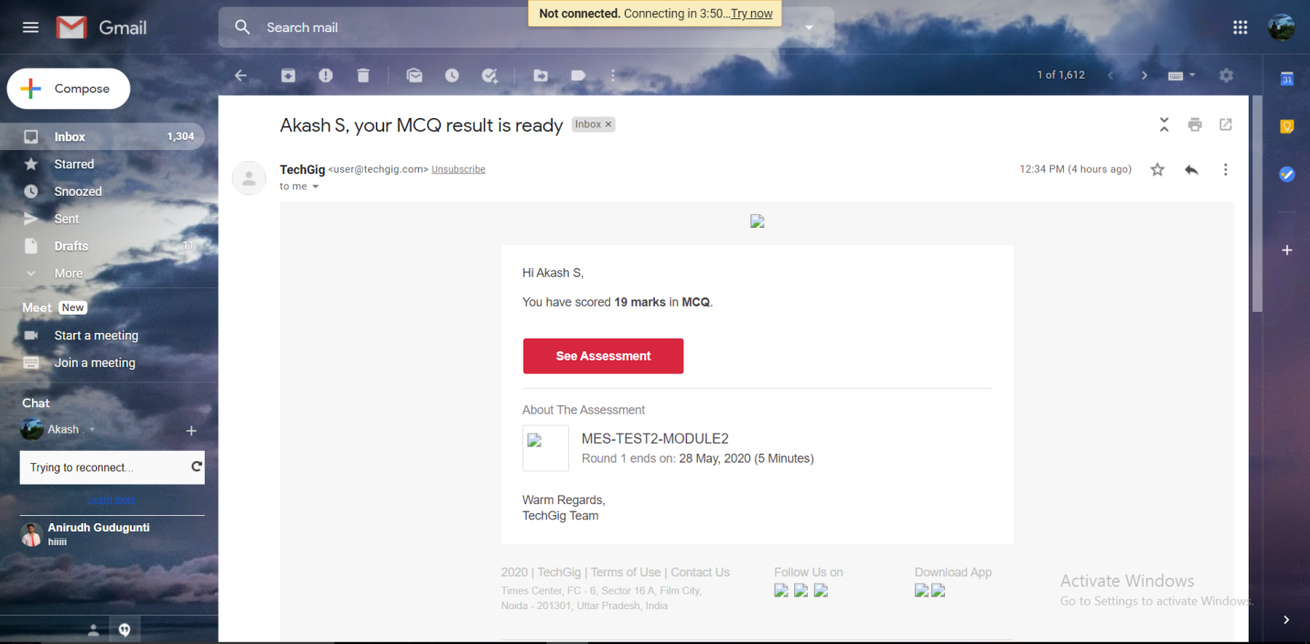

Online Certification course:

Today I written a assessment of java programming. and score I received was 08/10.

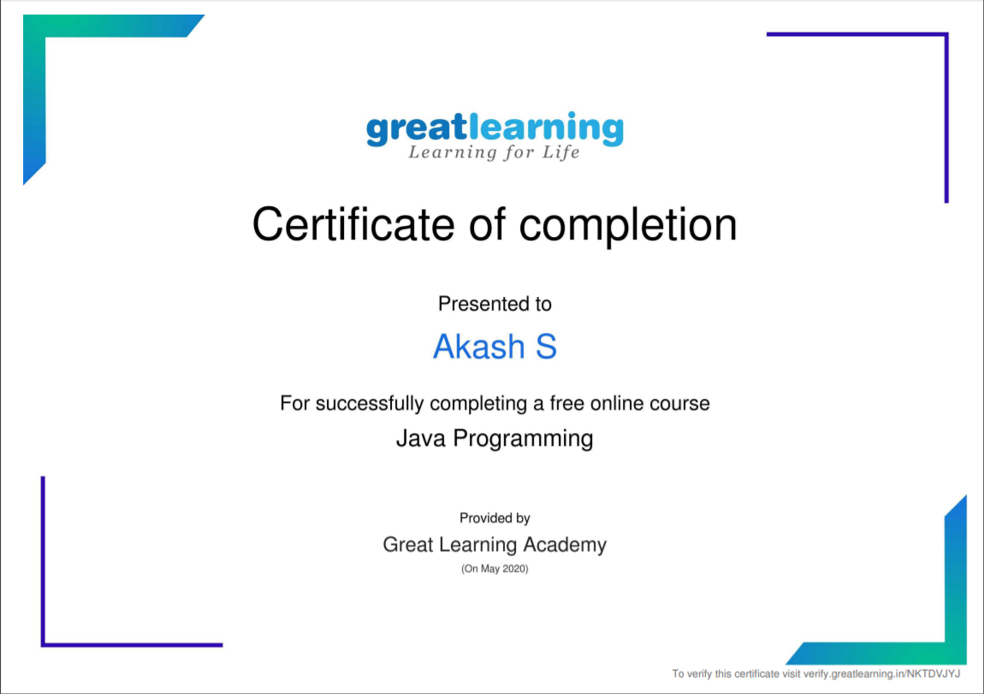

Today I started a new certification course

Name of the course : Introduction of python programming

Duration:4.5 hours

Certificate provider: udemy

The course contains 4 modules with 53 chapters. Today I completed 1 module.

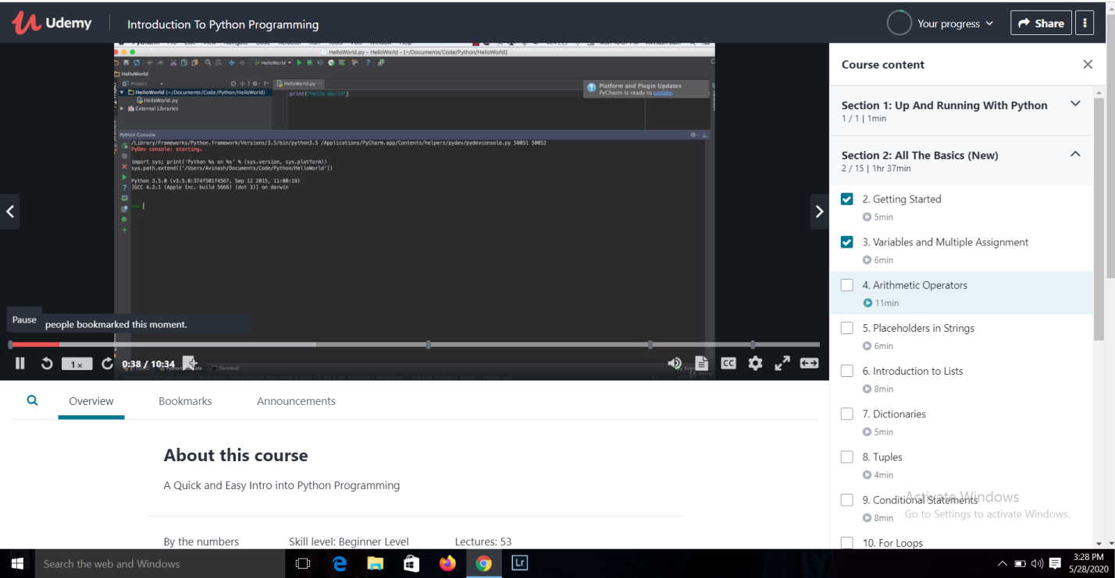

This the snapshot of the new course.

Online Coding summary:

1. C program to find digital root of a number

